1. Ecommerce
   1. Key Characteristics
      1. More customization options (have too many for current website loads)
      2. Hard to set inventory based on fabric usage (I only have 1 yard, how do I globally make sure the units aren’t over ordered?)
      3. I have lots and lots of options so I want to make sure they’re all available without being overwhelming
   2. Similar Websites
      1. Etsy/ GoImagine
         1. Enjoy the small handmade market feel
         2. The way products are set up (the product, how it’s made, who made it, are often easily found on the same page?)
      2. Nerdy Mommas
         1. Simple, clean feeling website. Does not feel overwhelming.
         2. Options are all on the product page and aren’t scattered across a thousand places.
2. Purpose and Goals
   1. Purpose
      1. Sell items, make fabric choice and sizes accessible
   2. Goals
      1. Primary
         1. Ease of use for custom items
         2. Fabric collection viewable
      2. Secondary
         1. Searchable catalog
         2. Completed sales
   3. Milestones
      1. Banner clicks
      2. Custom item
      3. Catalog time
      4. Added to cart
      5. Facebook/emails/newsletter
   4. Metrics
      1. All metrics
         1. Custom Orders
      2. KPI’s
         1. New Facebook Group members
   5. Analytics
      1. Google Analytics
         1. Track popular items/fabrics?
3. Website Content: Text and Images
   1. Website Copy
      1. Research work
         1. Look at other ecommerce sites as well as logos and style choice for branding
      2. Text
         1. Brand slogan
      3. Images
         1. Lookbook
         2. Product photos
         3. Fabric Samples
      4. Tools
         1. Coolers
            1. Color palette creator

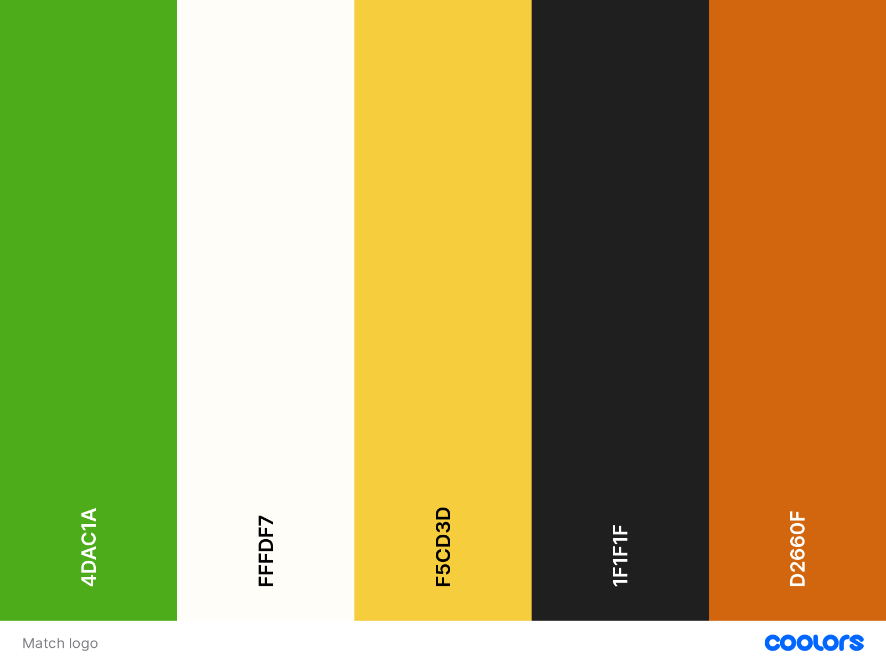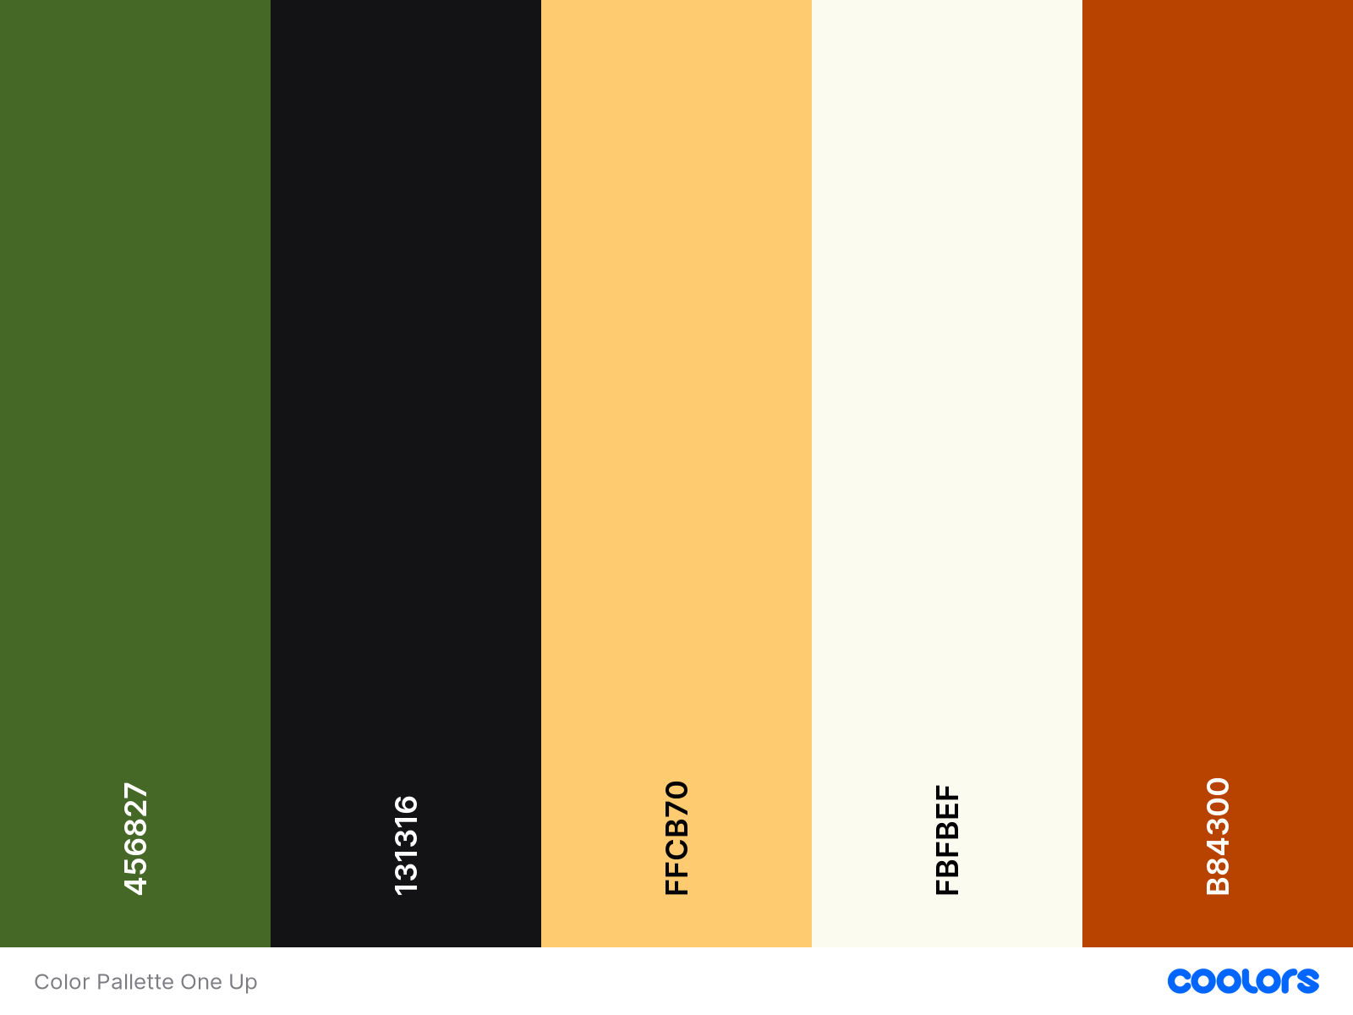

* + 1. Accessibility
       1. Description reader for photos

1. Website Content: Fundamentals
   1. Sitemap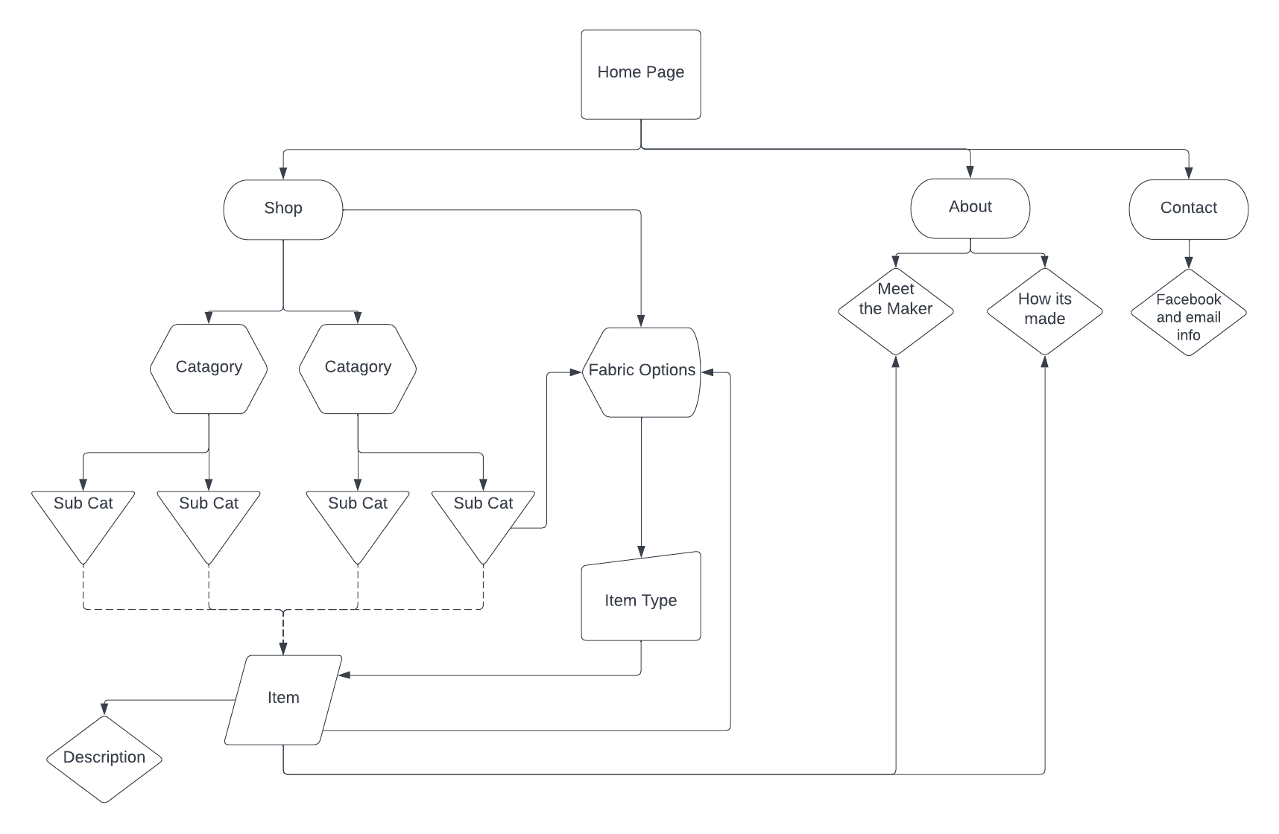

<https://lucid.app/lucidchart/8e07c35e-fbc1-4b90-b3cc-634ff24259c3/edit?invitationId=inv_d1ddb5c7-2658-4978-852a-c5e9728566b4#>

* 1. Layout considerations
     1. Keep things to one page for easy access, clear and concise layout
  2. Typography
     1. Font 1
        1. Brand
     2. Font 1
        1. readability
  3. Colors
     1. Green
        1. Brand
     2. Yellow
        1. Complimentary
     3. Orange
        1. Contrast
  4. Site wide accessibility considerations
     1. Readability
        1. Color contrast/colorblind accessible
  5. Functionality
     1. Cart check out
        1. Allow purchases
  6. Target Audience
     1. Moms that enjoy nerdy custom made items

1. Mock up
   1. Mock up design 1
      1. Desktop friendly with drop down menu
   2. Mock up design 2
      1. Mobile friendly with sidebar menu